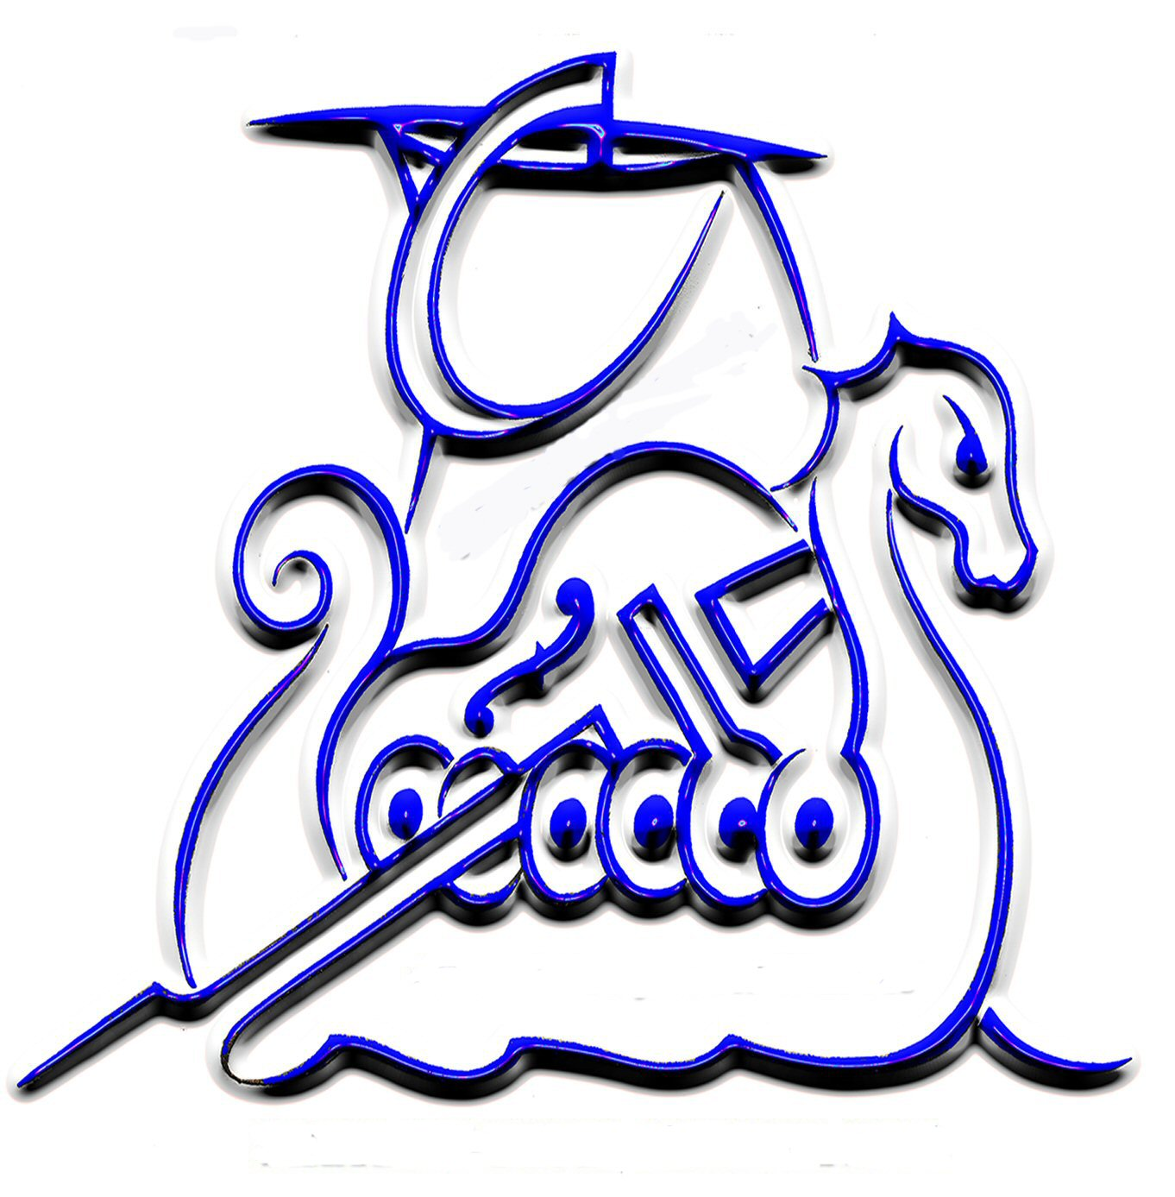 | Fourth Annual  Shetland Blues Festival  Friday August 31 to Sunday September 2 2007  PRESS RELEASE
The fourth Shetland Blues festival is set to take place in various venues throughout Shetland over the weekend of the 31 August to 2 September 2007. The lineup of visiting acts are Blues N Trouble, the Cadillac Kings, Dave Arcari, Molly Brown and Son Henry and they cover all aspects of the blues from Chicago style, jump blues and the new alt blues scene.
Blues n Trouble are still an exciting live band to catch having been on the blues scene in the UK for over 25 years now. They should be familiar to quite a few Shetlanders who attended college or university in Edinburgh in the 1980's. The band lead by vocalist Tim Elliot will be playing two shows over the weekend and guitarist Sandy Tweedale will do a solo gig over the weekend as well.
B'n'T were formed in the early 80 's by Tim Eliott & John Bruce. Constant personnel changes were to eventually lead to a permanent line-up, which encouraged the band to turn professional & saw the release of their debut album in 1985.
During the next ten years B'n'T toured & guested with many blues greats including BB King, Robert Cray, Pinetop Perkins, Charlie Musselwhite, Buddy Guy & Junior Wells. They recorded with Lazy Lester in 1987 on his comeback album "Lazy Lester Rides Again" for which a W.C.Handy award was won in 1988!
Their third album, "Hat Trick", recorded by vintage blues producer Mike Vernon relaunched his "Blue Horizon" label. Chart success with "No Minor Keys" & "Hat Trick", along with a British Blues Connection award for "Down to the Shuffle", helped keep the band in high demand for many years, often playing around 250 shows a year all over the U.K., Scandinavia & Europe.
They have appeared at festivals throughout the world including the prestigious "Memphis Blues Festival". B'n'T have released 9 albums, not including re-issues & compilations.
Featuring six of the UK's top blues & roots musicians, The Cadillac Kings play music inspired by the sounds & styles of the ‘40s & ‘50s. A mix of mostly original songs with a few well-chosen covers from the likes of T-Bone Walker, Roy Brown & Champion Jack Dupree have made the band firm favourites on both the blues & jump-jive scenes. With their stunning musicianship & exciting stage act, this is a band that knows how to entertain audiences across the board, from arts centres to dance-halls, from intimate clubs to major festivals.
With backgrounds including Otis Grand’s Band, James Hunter’s Jokers, The Poorboys, Big Joe Louis, and Little George Sueref, The Cadillac Kings came together in the year 2000. They became an immediate hit at venues & festivals all over the UK . 2001 saw the release of their debut CD ‘Lou Ann’ which received wide airplay in the UK & abroad, culminating in a nomination for the 2002 USA Swing Awards. Tour dates have included London’s 100 Club, the Colne Great British R&B Festival, the Burnley Blues Festival, London's Hackney Empire, the Black Horse World Music Festival in Sussex, Crawley Folk Festival, Soho Jazz & Heritage Festival, UK Arts Council tour, the Gloucester Blues Festival, (Norway's huge) Notodden Blues Festival, the Ørland Blues Fest, the Drobak Festival, Denmark's annual Blues Cruise, the Duvel Blues Festival in Belgium & the Rotterdam Bluezy Festival in Holland.
Now signed to ‘33’ Records, November 2004 saw the release of the band’s second CD ‘Highway 17’, which in December 2004 the music critics of The London Times agreed and included 'Highway 17' in their list of the best 24 CDs of the year and chose it overall best blues CD.
More recently, and for the third year in succession, The Cadillac Kings have won the categories for 'best blues band' & 'best harmonica player' in the 2005 Wychwood Brewery/ Running Horse Awards, as voted for by the audiences at Nottingham's top live blues venue.
SLIDE guitarist & songwriter Dave Arcari is best known as frontman of alt.blues band Radiotones which has three internationally-acclaimed albums under it's belt.
His debut solo EP Blue Country Steel was launched during a nine-night run of shows at Edinburgh Festival Fringe. There are three new CD releases on Buzz Records– Something old, something borrowed (BRS012006 – release date 4 Sept 2006), Something new, something blue (BRS022006 – release date 6 Nov 2006) and Come With Me (BRS032006 – release date 5 Feb 2007).
A series of shows with the mighty Alabama 3 (by personal request from the band), gigs with Son of Dave and Jon Spencer and a summer 2005 tour in Estonia (including headline slots at the Augustibluus Festival) have now established Arcari as a formidable international solo performer and attracting a media reputation as a 'hell-raising National guitar madman'.
In 1996 he quit his first proper band role as guitarist with Summerfield Blues (which won the Alexis Korner memorial trophy for 'Scottish Blues Band of the Year' at Edinburgh International Blues fest in 2003 - the same year the band released it's debut, and only, CD album Devil & the Freightman) to concentrate on his new found National steel guitar.
So while the electric Nationals and Marshall stack are on the back burner for Dave's solo appearances, his hard-hitting gravel-laden vocals and slashing bottleneck steel guitar make for an aggressive, dynamic blues-based sound that owes as much to punk, rockabilly and trash country as pre-war Delta blues.
Dave's most recent single was inspired by the Robert Burns poem Parcel Of Rouges for which he did a program on BBC Radio Scotland about the history surrounding the poem.
Ex-Alaskan, now living in Scotland, Son Henry is, quite simply, a musician that lives and breathes the blues. However, that comes as no surprise to the legions of faithful. They know to turn out in all kinds of weather so they can be close to the fire generated every time this man picks up a guitar. In Alaska where the bars sometimes never close, he's been known to hold an audience until the sun-lit hours of the next morning when they really should be at home getting dressed for work, so he should feel at home in Shetland.
He's made a startling range of styles his own, from deep soulful delta blues to loping Texas Shuffles and all points in between. Original tunes that sound like they were written in decades past. But be warned- it's when the lap steel guitar comes out that you need to stand back.
Playing their own brand of 'good-time, feel-good music' played with energy, passion and entertainment. You can't help but be impressed and knocked out by them!'
Molly Brown generate a warm mixture of 'Blazz and Bling' (that's blues, jazz and swing to you and I), and their love and passion for music, combined with a desire to entertain, has delivered a welcoming response from audiences around the globe, since forming in 2003.
As an semi-acoustic outfit, Molly Brown is light on the ears and yet loaded with fun and will have you smiling from start to end.
Local bands playing at this year’s festival include the Rumshack Blues Band, the Donald Anderson band, Red Hot and Blue, Matt Vinyl, Jamiesons’ Big Pockets and new local act the Gordon Tulloch Experience.
Tracks from the visiting artists can be heard on the Blues festival website at www.shetlandblues.info as well as a podcast on the Zetcast.com website.
The program will be available in the next couple of weeks.

